A List of English Prepositions (not complete!)

In English, there are around 100 prepositions. Here are 46 of them, with examples:
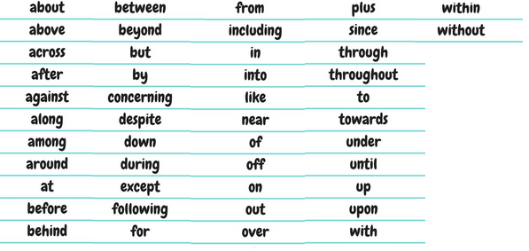

Come on in out
of the cold!

Examples:
- I am thinking about going to Europe.
- We are flying above the clouds.
- They built a bridge across the river.
He walked across the bridge.
- I always drink coffee after dinner.
- The English fought against the Germans in WWII.
He walked against the wind.
- We enjoy walking along the river.
- There is a fox among the chickens.
- We ran around the park three times yesterday.
- Every day I go to bed at 11pm.
A: Where is John? B: He is at work.
A: Where is John? B: He is at his desk.
- I brush my teeth before going to bed.
- The cat is behind my chair.
- The TV control has fallen between the cushions.
- Man wants to travel beyond our solar system.
- I want to eat in a restaurant, but I don’t have any money.
- She always goes to work by car.
The play was written by Shakespeare.
I’ll be home by 6pm.
I learn English by watching YouTube.
- I want to speak to you concerning your school grades.
- We went to the beach despite the bad weather.
- Let’s go down in the elevator.
- I only travel during the summer.
- I passed all my school tests except mathematics.
- Following many days of rain, we had a sunny day.
- I bought flowers for my wife.
- Bob received a new watch from his father.
- I speak many languages, including French and German.
- The cat is in the box.
- The cat jumped into the box.
- My baby sleeps like an angel.
- I live near the park.
- Thomas is the author of many books.
- Please take your shoes off before you come in.
- The book is on the table.
- Please take out the trash.
- Thousands of cars drive over the river every day.
- The loan must be repaid, plus interest, by the end of the year.
- I can’t go out this weekend since I don’t have any money.
I haven’t seen him since January.
- Alice looked through the window.
John walked through the park.
- I stayed awake throughout the night.
London was bombarded throughout the war.
- I always drive to work.
I gave flowers to my wife for her birthday.
Fred is married to Susan.
- The captain steered the ship towards the port.
- The cat is under my desk.
- I always stay at work until 6pm.
- He went up the stairs to go to bed.
- You will receive an access code upon payment.
- David went to France with his mother.
I agree with you.
- I will arrive within an hour.
I believe that programming is within your capabilities.
- I went to the city centre without my umbrella.
I can’t live without you!

For a more comprehensive list of prepositions, visit the site:
https://www.thefreedictionary.com/List-of-prepositions.htm

